Hackathon 3 – 9/23/19

-- #1

-- Write a query that provides a current head count by each department with a subtotal.

-- Hint: Use WITH ROLLUP keyword

select

dp.dept_name,

format(count(de.emp_no), 0) as 'Employees'

from dept_emp de

inner join departments dp

on de.dept_no = dp.dept_no

where year(to_date) = 9999

group by dept_name with rollup;

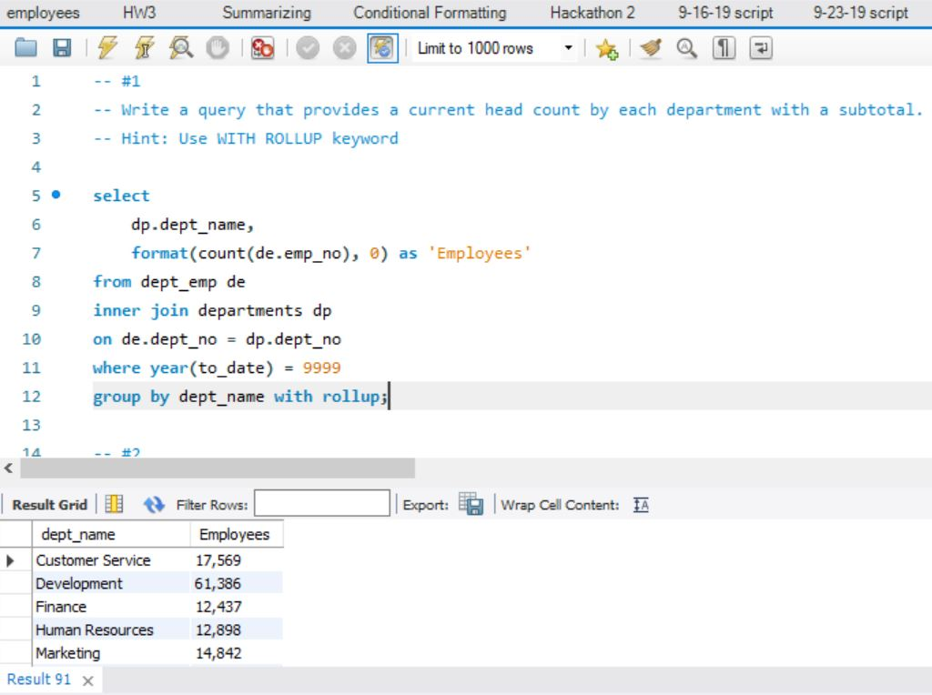

-- #2

-- Write a query that uses an inner join to return a table with all columns from salaries and employees

select *

from salaries s

inner join employees e

on s.emp_no = e.emp_no;

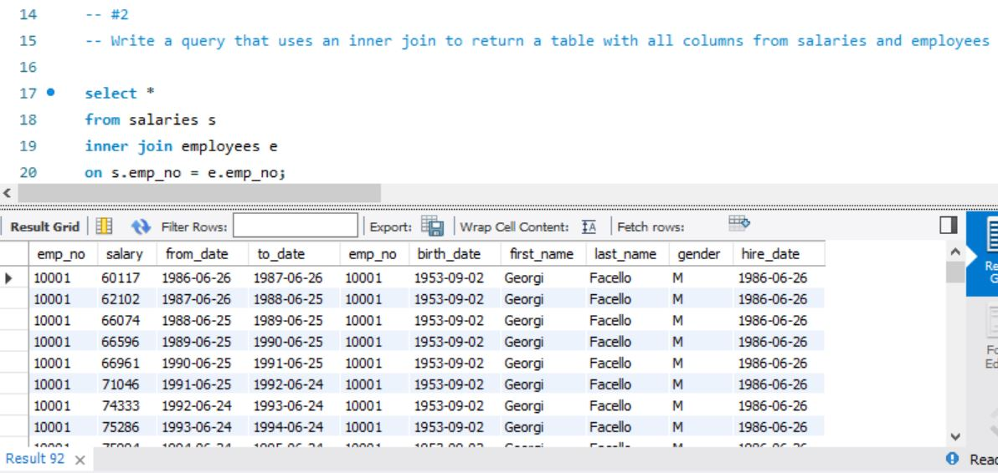

-- #3

-- Write a query that returns the complete salary history and demographic information for employee

-- number = 10002

select *

from salaries s

inner join employees e

on s.emp_no = e.emp_no

where s.emp_no = 10002;

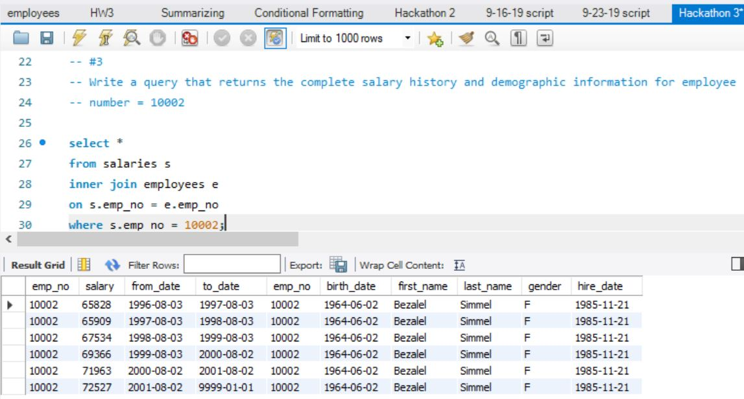

-- #4

-- Write a query that returns the following columns: emp_no, full name (first_name + last_name),

-- and current salary for all employees

select

e.emp_no,

concat(first_name,' ',last_name) as 'Name',

format(s.salary, 0) as 'Salary'

from employees e

inner join salaries s

on e.emp_no = s.emp_no

where year(to_date) = 9999;

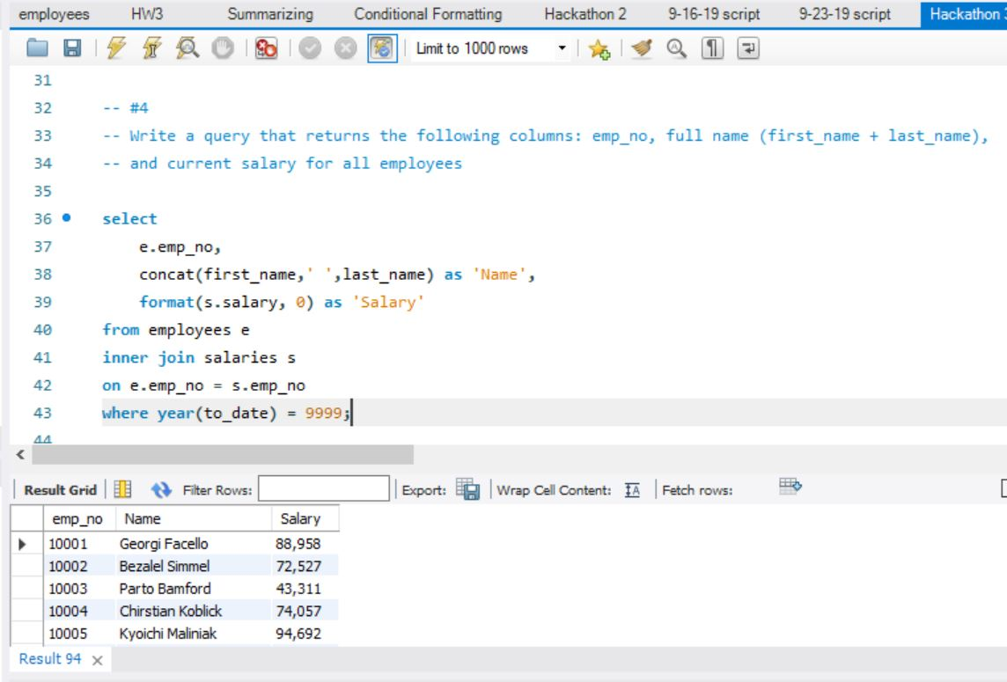

-- #5

-- Revise the query in #3 to include a column for the employee’s job title

select

e.emp_no,

concat(first_name,' ',last_name) as 'Name',

format(s.salary, 0) as 'Salary',

t.title as 'Title'

from employees e

inner join salaries s

inner join titles t

on e.emp_no = s.emp_no

and e.emp_no = t.emp_no

where year(s.to_date) = 9999;

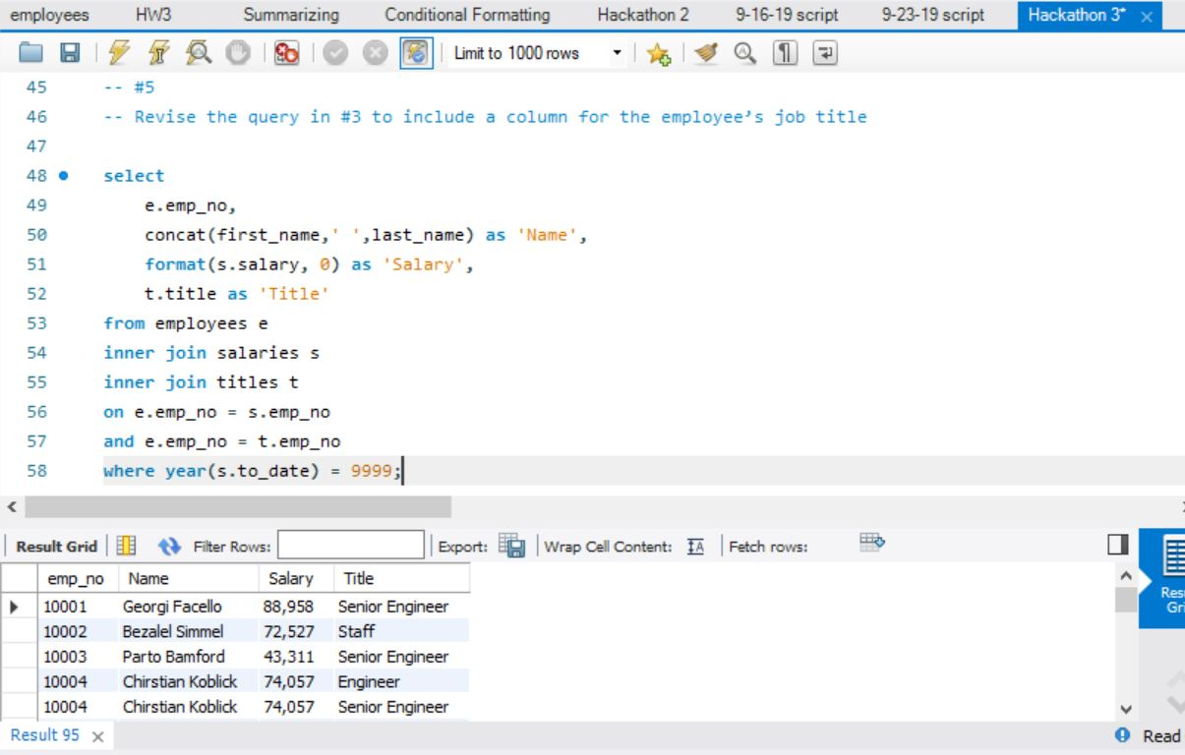

-- #6

-- What is the name of the department that Georgi Facello works in?

select

concat(first_name,' ',last_name) as 'Name',

dept_name as 'Department'

from employees e

inner join dept_emp d

inner join departments dp

on e.emp_no = d.emp_no

and d.dept_no = dp.dept_no

where e.emp_no = 10001;

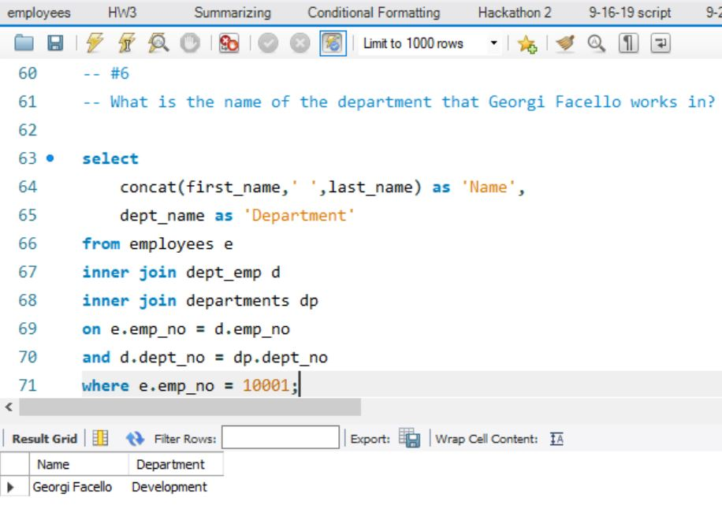

-- #7

-- Who is Georgi Facello’s manager?

select

concat(e.first_name,' ',e.last_name) as 'Name',

concat(em.first_name,' ',em.last_name) as 'Manager'

from employees e

inner join dept_emp d

inner join dept_manager dm

inner join employees em

on e.emp_no = d.emp_no

and d.dept_no = dm.dept_no

and dm.emp_no = em.emp_no

where e.emp_no = 10001

and year(dm.to_date) = 9999;

